**Introduction :**

"The E-Ration management" web application is designed for serving public people for ration supply where each individual will have a ration card whose data will be stored in a database while distributing ration items to the customer.

A ration cardholder should be given food grain as per the norms of the Government.However, there are concerns about the authenticity of the distribution process. To overcome this problem and improve the current system of the Ration distribution process we are implementing this ration management project. Here we are going to develop a web application for Ration management. Using the Ration management web application, the distributor can easily store the authentic card-holder's data and use the stored data for Ration distribution in the future.

The main reason for using this application is making this process computerized and to remove the drawbacks of the present way of storing card holder's data. The main drawback in the current system is that the Public Food Distributor has been criticized for its urban bias and its failure to serve the poorer sections of the country effectively.

**Literature survey** :

The E-Ration management system is developed using following languages and implementation modules :

1. **HTMl** :

* HTML stands for Hyper Text Markup Language.
* HTML is the standard markup language for creating Web pages.
* HTML describes the structure of a Web page.
* HTML consists of a series of elements.
* HTML elements tell the browser how to display the content.

1. **CSS** :

* CSS stands for Cascading Style Sheets
* CSS describes **how HTML elements are to be displayed on screen, paper, or in other media**
* CSS **saves a lot of work**. It can control the layout of multiple web pages all at once
* External style sheets are stored in CSS files

1. **PHP** :

* PHP is an acronym for "PHP: Hypertext Preprocessor"
* PHP is a widely-used, open source scripting language
* PHP scripts are executed on the server
* PHP is free to download and use

1. **BOOTSRAP** :

* Bootstrap is a free front-end framework for faster and easier web development
* Bootstrap includes HTML and CSS based design templates for typography, forms, buttons, tables, navigation, modals, image carousels and many other, as well as optional JavaScript plugins
* Bootstrap also gives you the ability to easily create responsive designs

1. **SQL** :

* SQL stands for Structured Query Language
* SQL lets you access and manipulate databases
* SQL became a standard of the American National Standards Institute (ANSI) in 1986, and of the International Organization for Standardization (ISO) in 1987

**XAMPP** :

It is a free and open-source cross-platform [web server](https://en.wikipedia.org/wiki/Web_server" \o "Web server) [solution stack](https://en.wikipedia.org/wiki/Solution_stack" \o "Solution stack) package developed by Apache Friends,[[3]](https://en.wikipedia.org/wiki/XAMPP" \l "cite_note-kaiseidlerinterview-3) consisting mainly of the [Apache HTTP Server](https://en.wikipedia.org/wiki/Apache_HTTP_Server" \o "Apache HTTP Server), [MariaDB](https://en.wikipedia.org/wiki/MariaDB" \o "MariaDB) [database](https://en.wikipedia.org/wiki/Database" \o "Database), and [interpreters](https://en.wikipedia.org/wiki/Interpreter_(computing)" \o "Interpreter (computing)) for scripts written in the [PHP](https://en.wikipedia.org/wiki/PHP" \o "PHP) and [Perl](https://en.wikipedia.org/wiki/Perl" \o "Perl) [programming languages](https://en.wikipedia.org/wiki/Programming_language" \o "Programming language) Since most actual web server deployments use the same components as XAMPP, it makes transitioning from a local test server to a live server possible.

XAMPP's ease of deployment means a WAMP or [LAMP](https://en.wikipedia.org/wiki/LAMP_(software_bundle)" \o "LAMP (software bundle)) stack can be installed quickly and simply on an operating system by a developer, with the advantage that common add-in applications such as [WordPress](https://en.wikipedia.org/wiki/WordPress" \o "WordPress) and [Joomla!](https://en.wikipedia.org/wiki/Joomla!" \o "Joomla!) can also be installed with similar ease using [Bitnami](https://en.wikipedia.org/wiki/Bitnami" \o "Bitnami). systems even when owing to its less size it takes a load on the processor speed.

**Design** :

1. **R Diagram** :

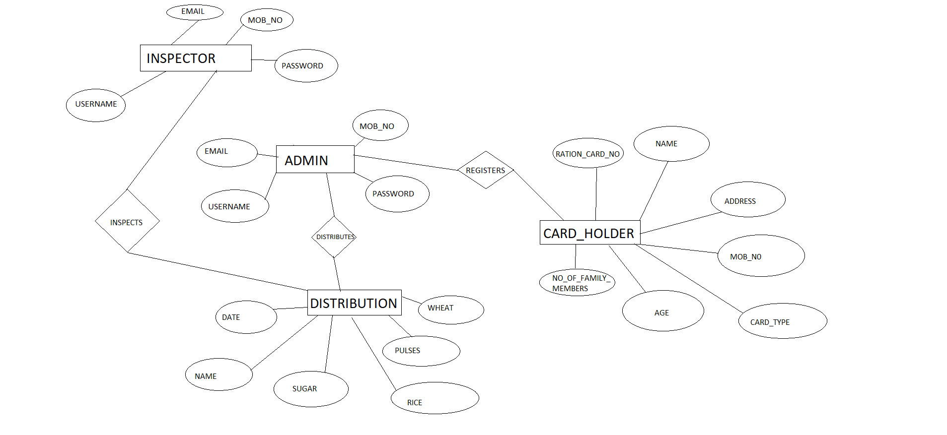

**Relation Schema Diagram :**

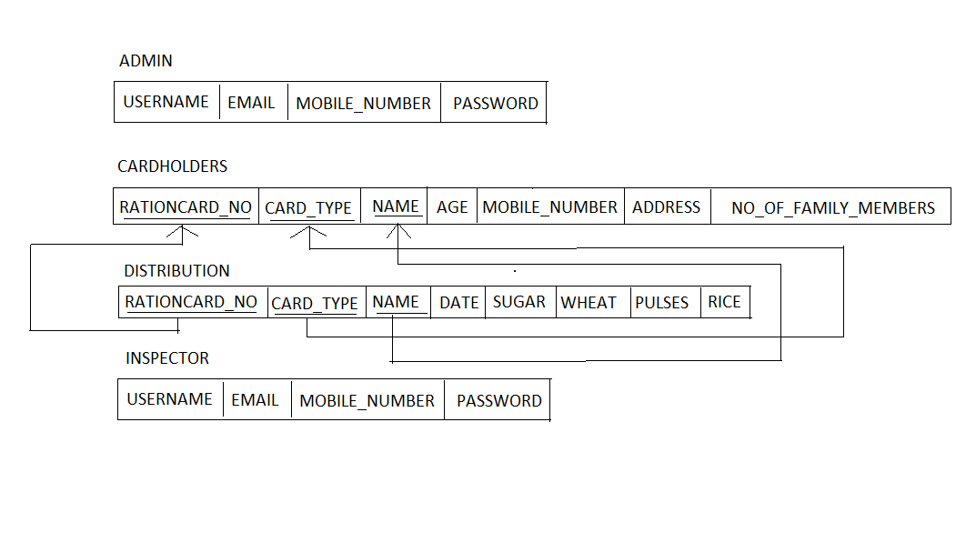

**Implementation :**

**Login:**

**Php code for Admin Login**

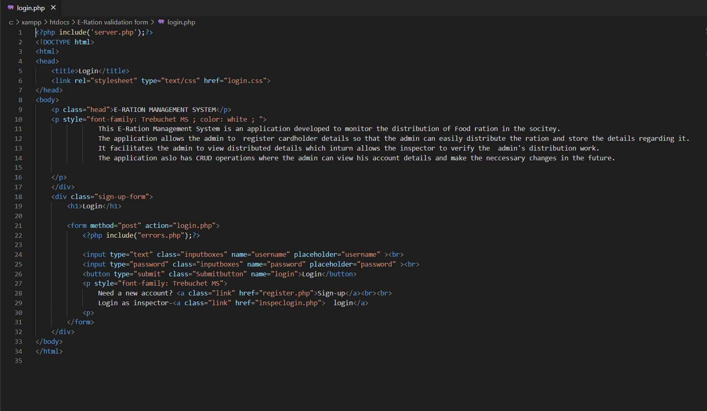

**Register :**

**Php code for Admin Register**

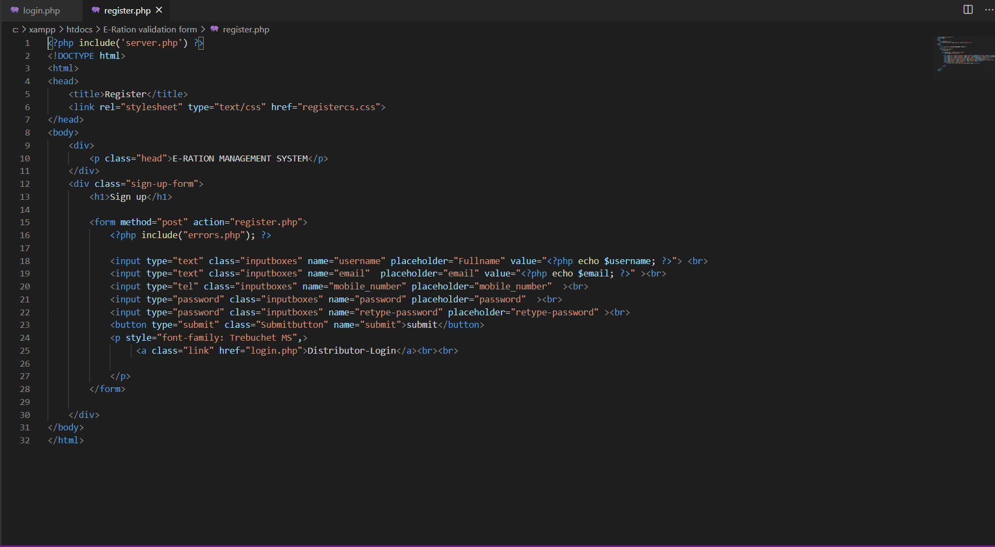

**Index(customer registration):**

**Php code for Customer Registration**

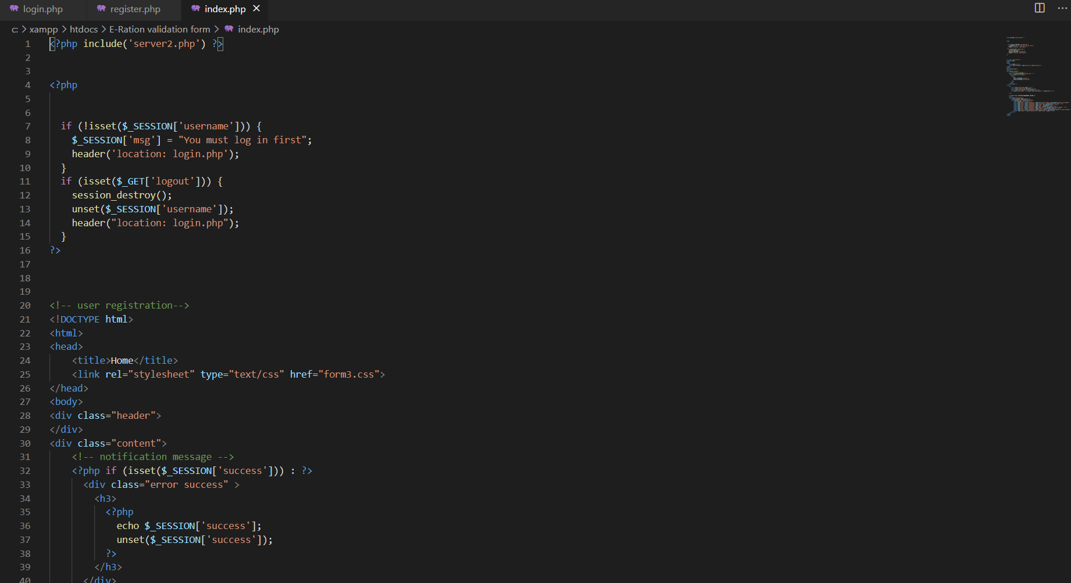

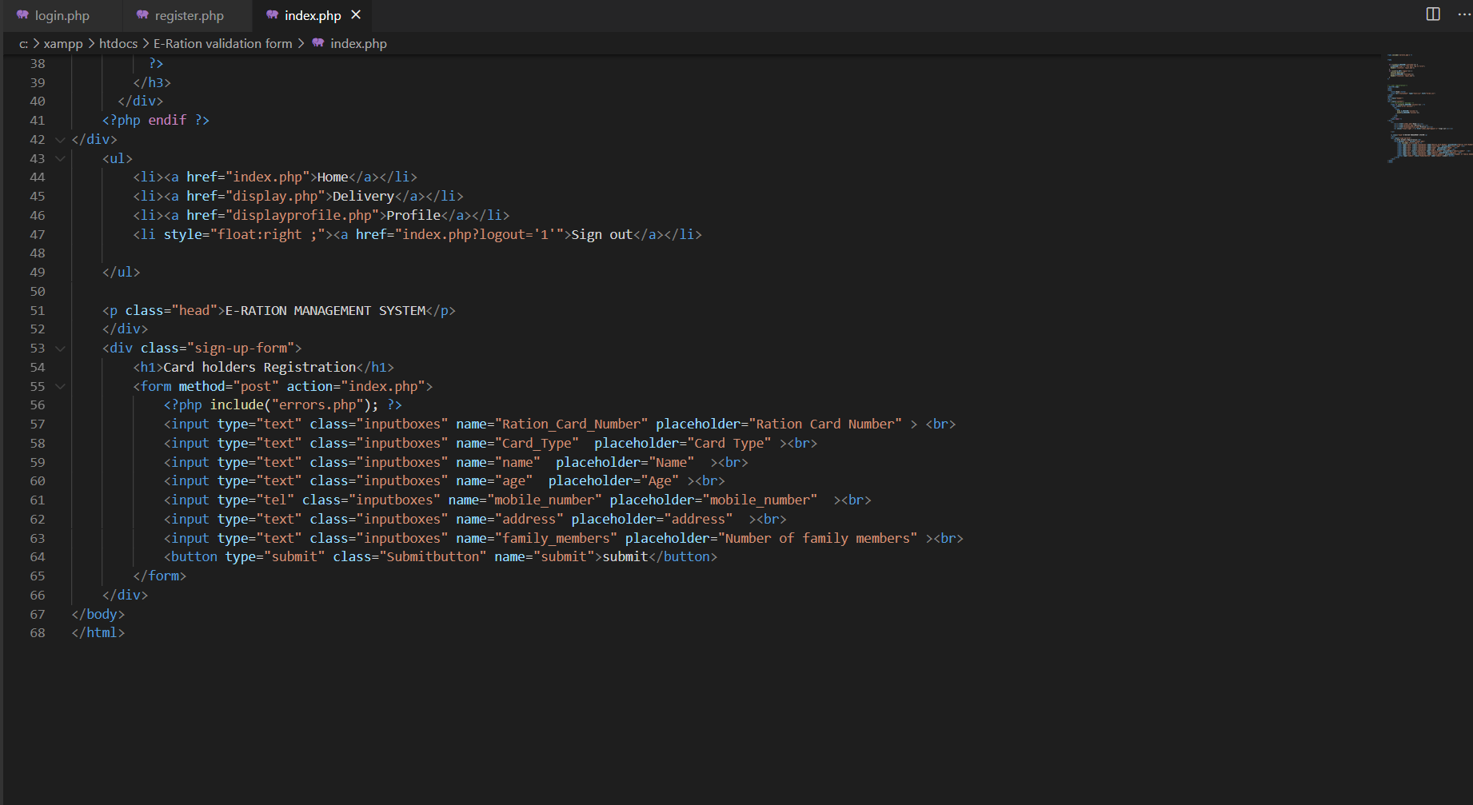

**Customer details :**

**Php code for Viewing Customer Details**

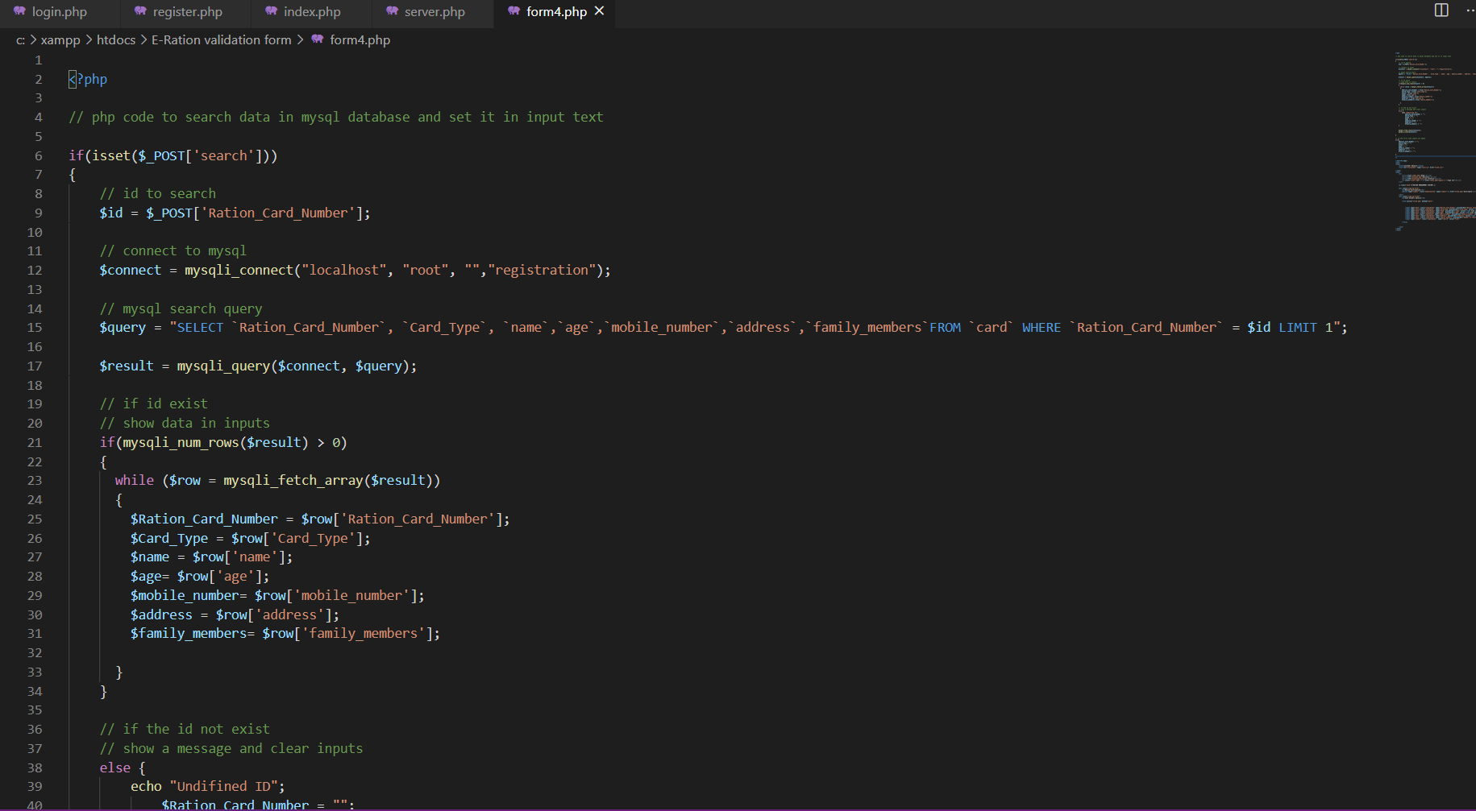

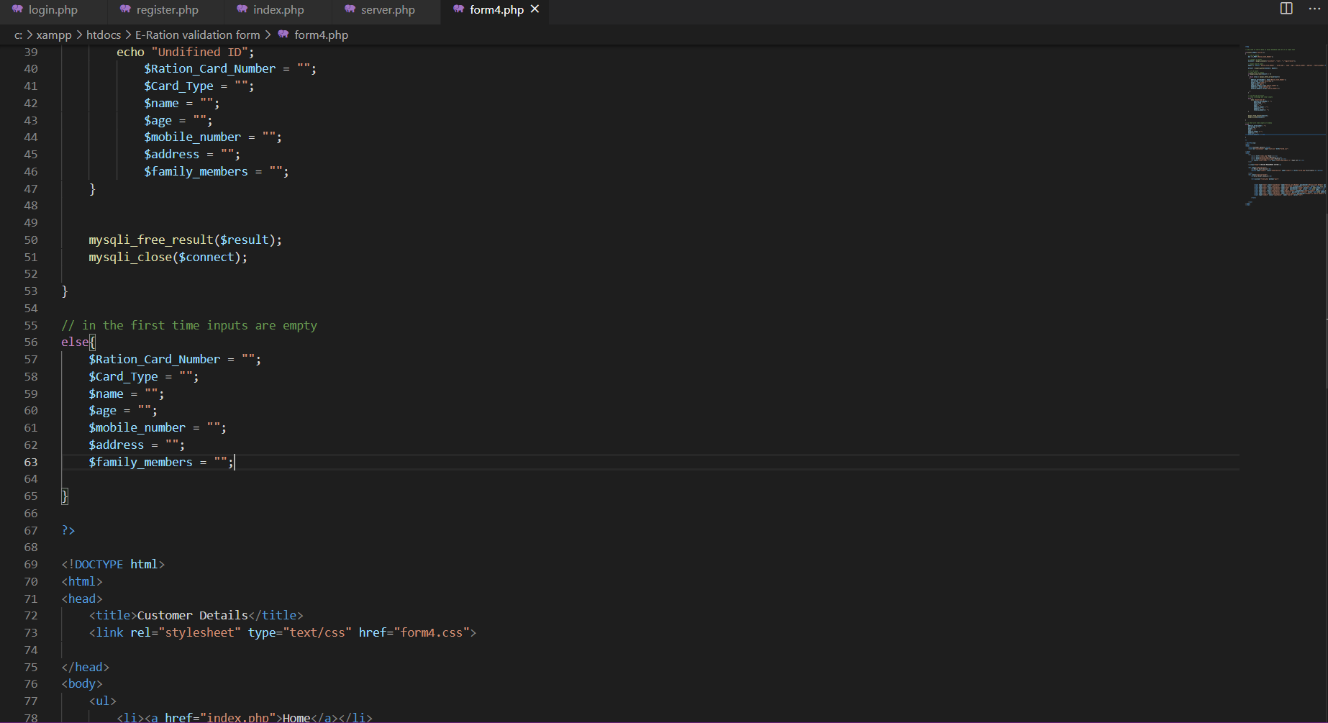

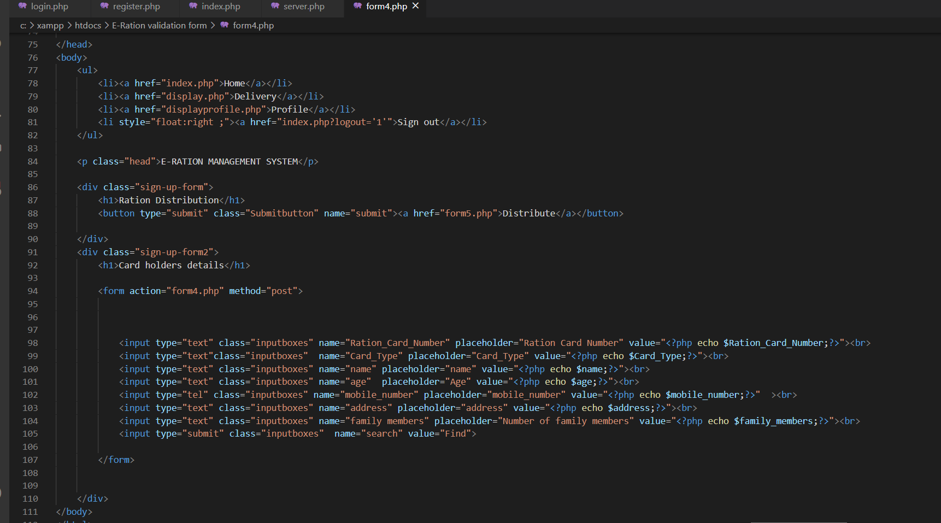

**Distribution :**

**Php code for Ration distribution**

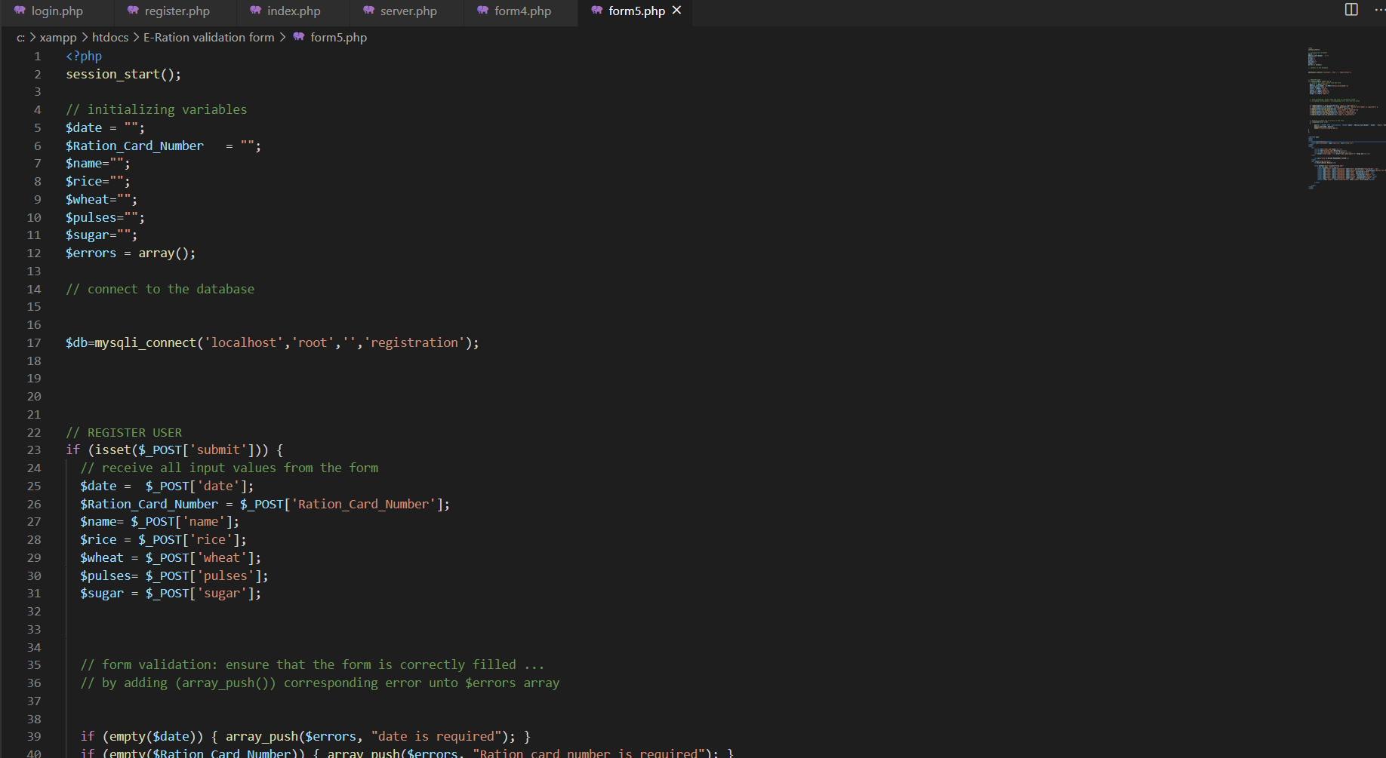

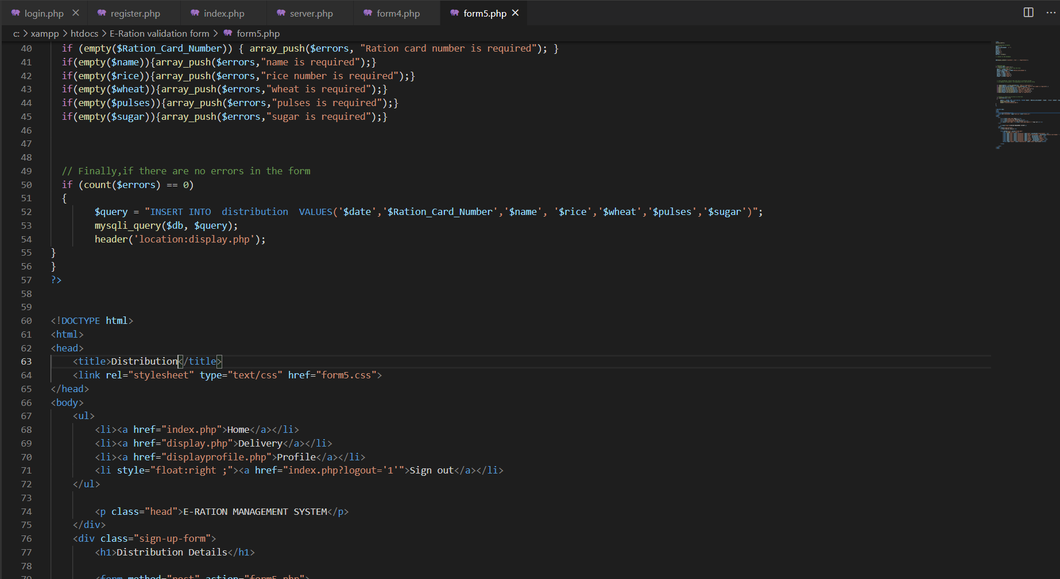

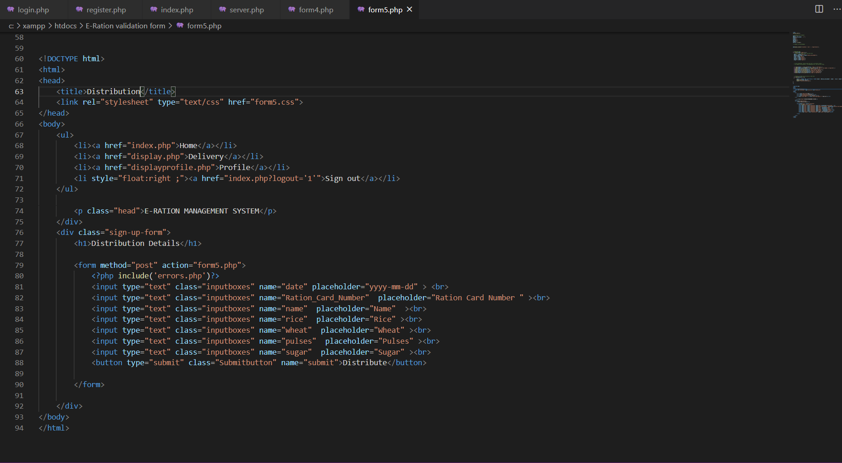

**Display Profile :**

**Php code for Admin Profile**

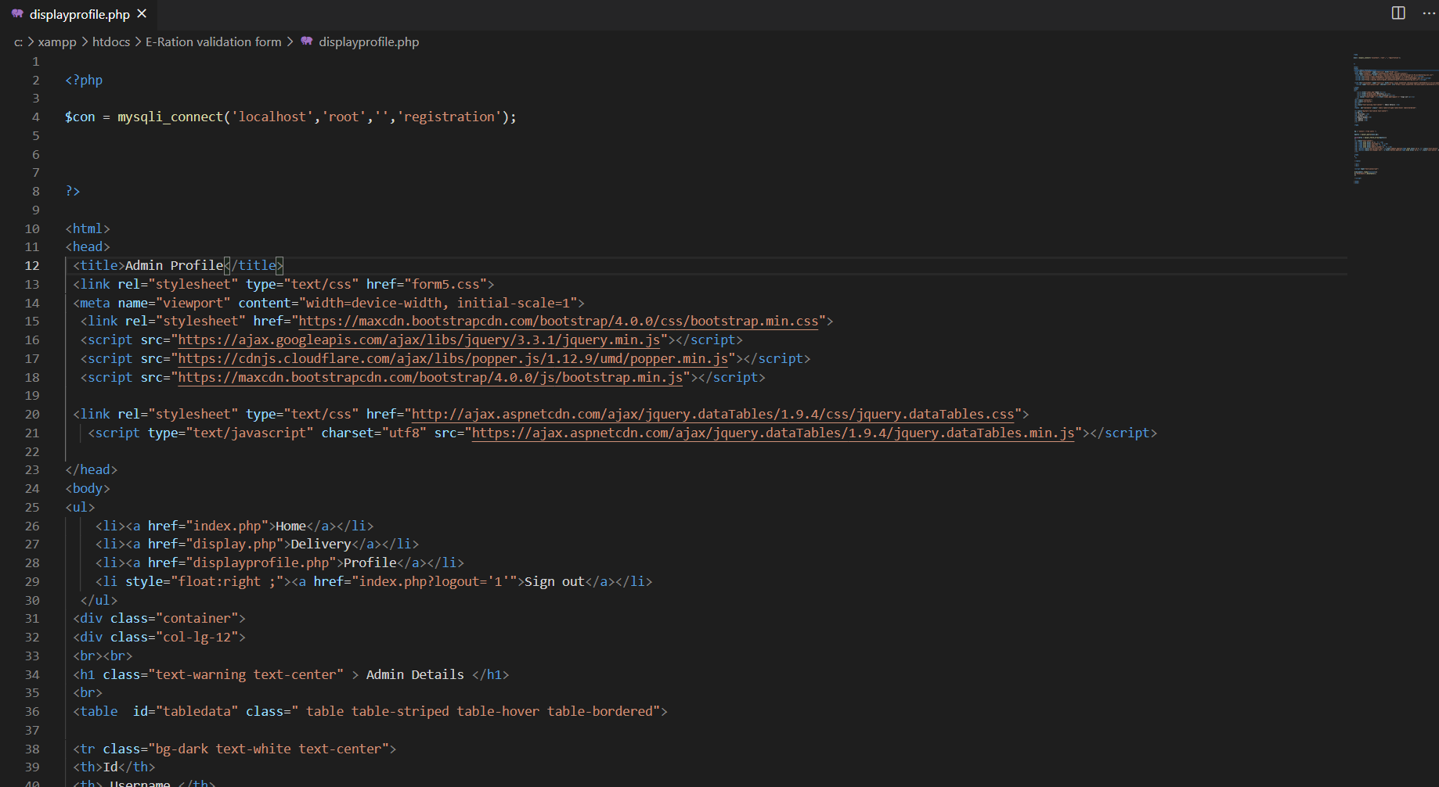

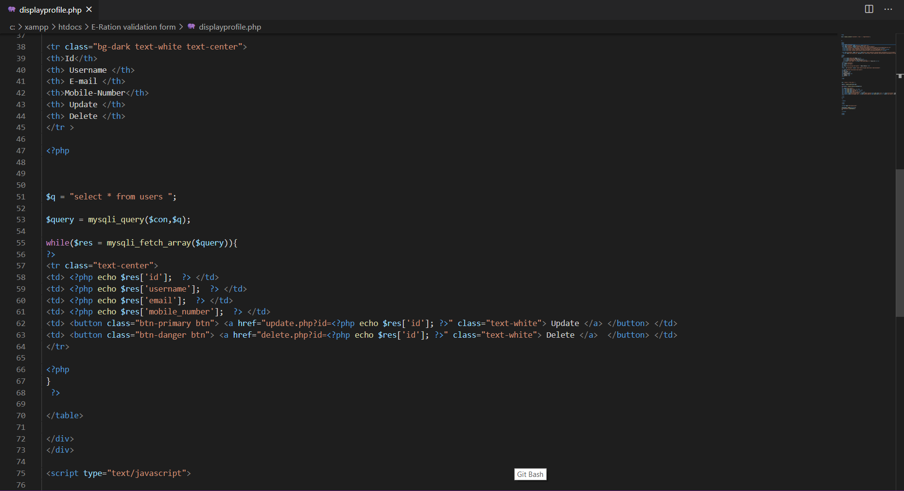

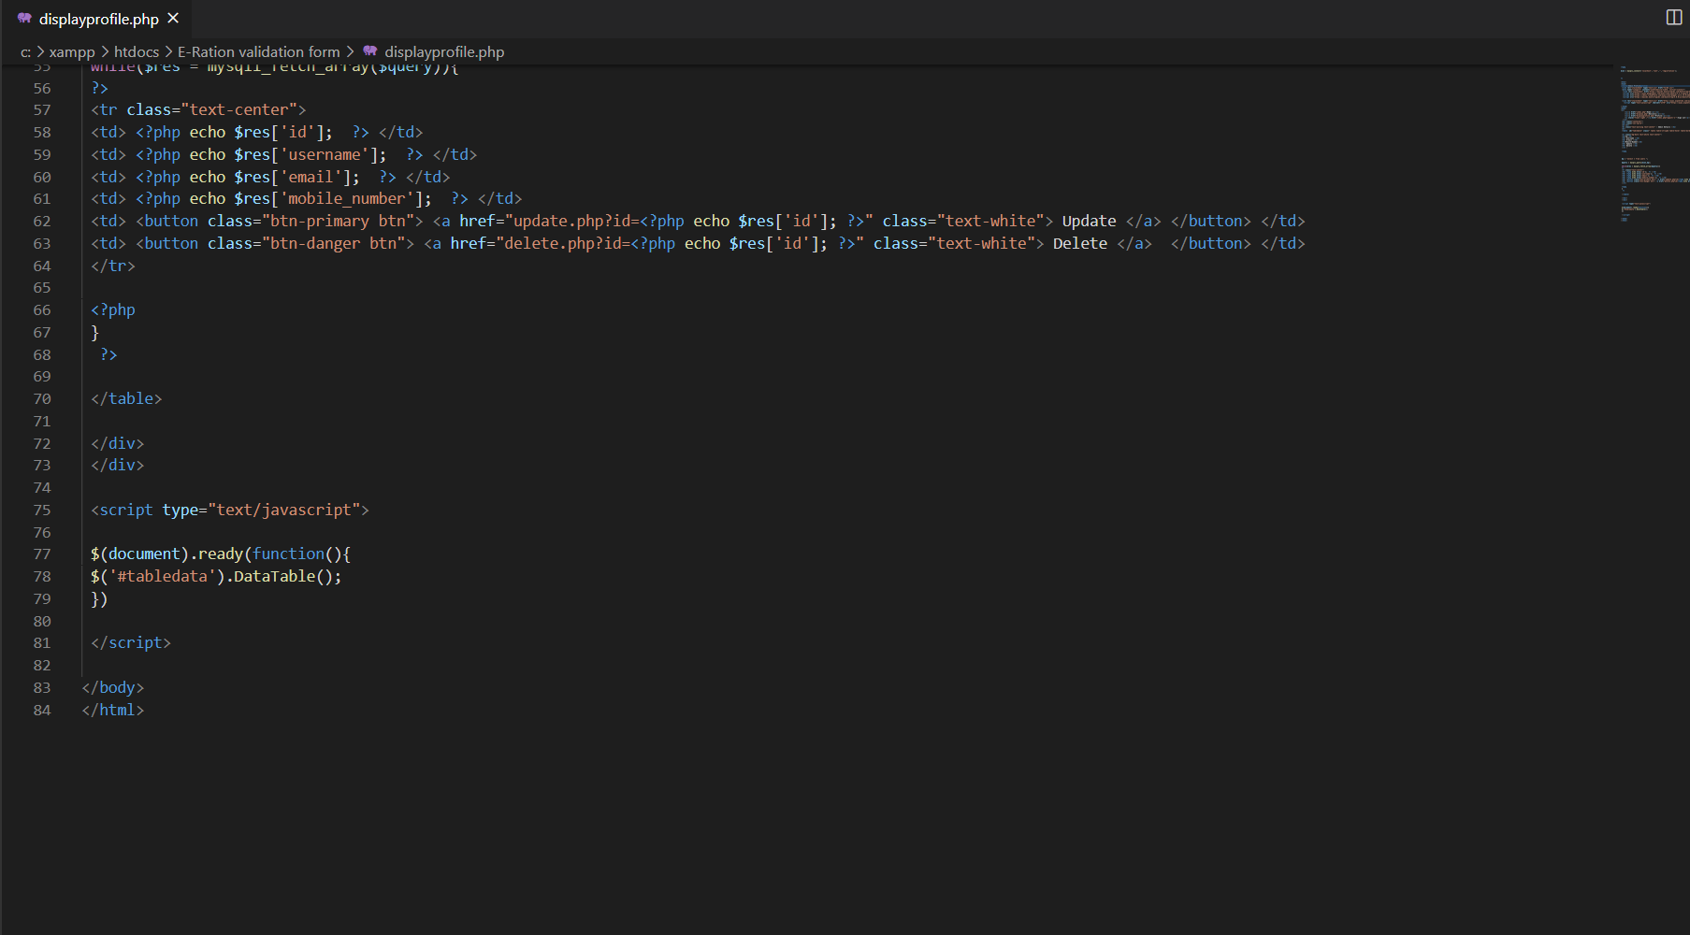

**Css :**

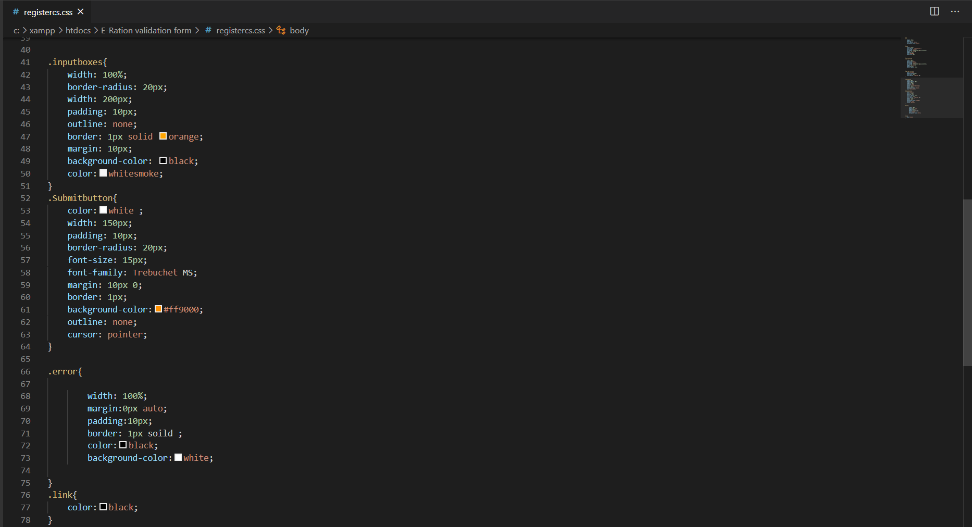

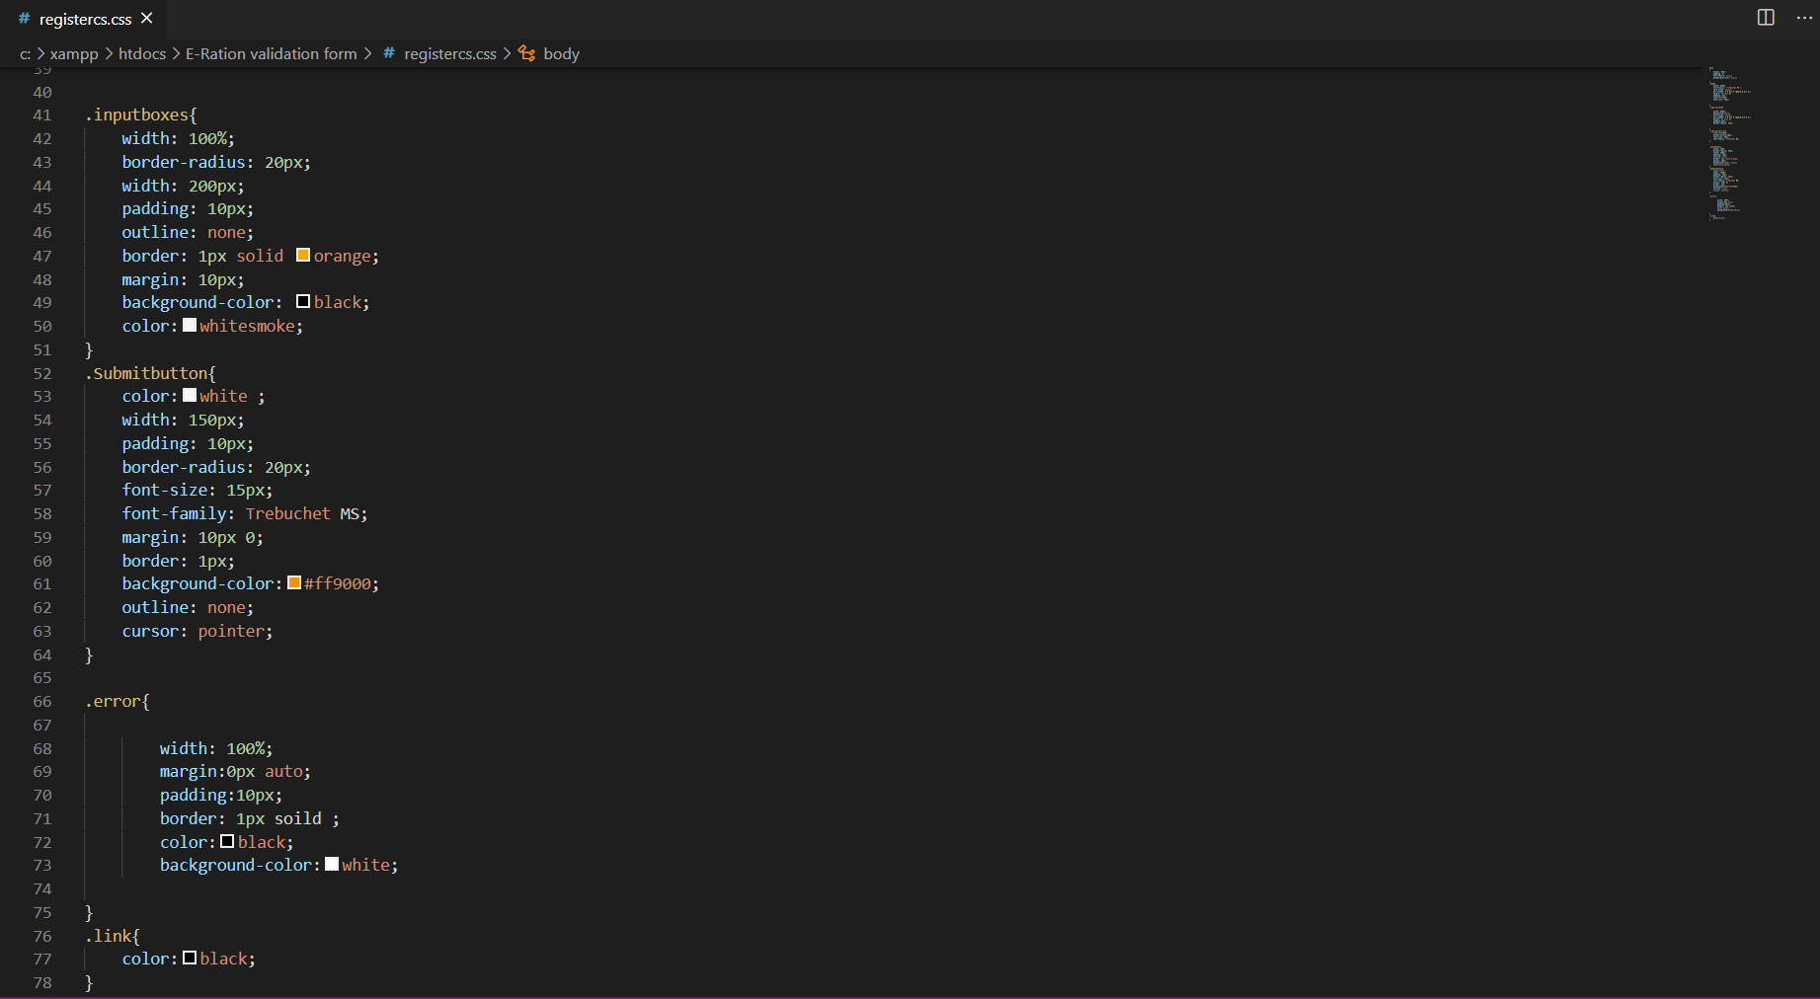

**Css for Profile :**

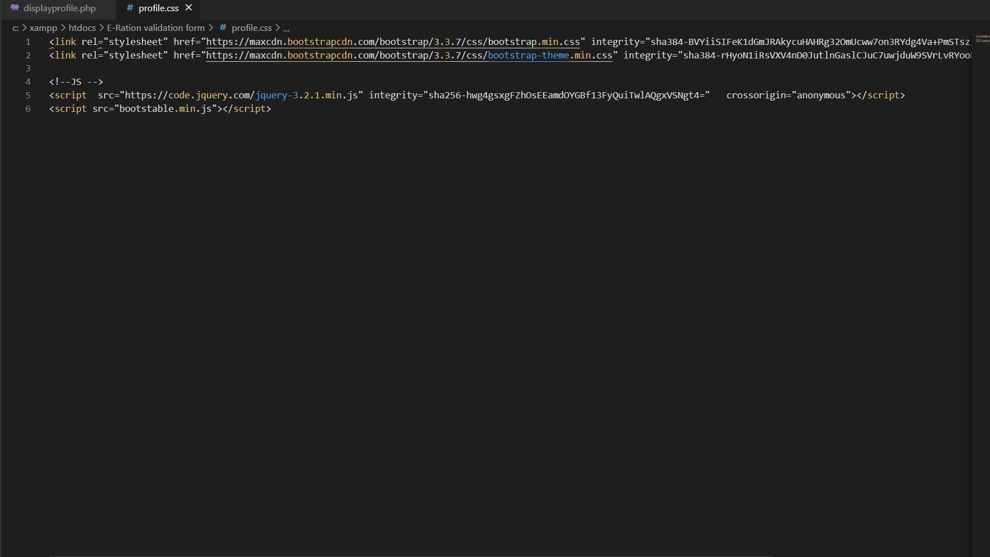

**Server Module:**

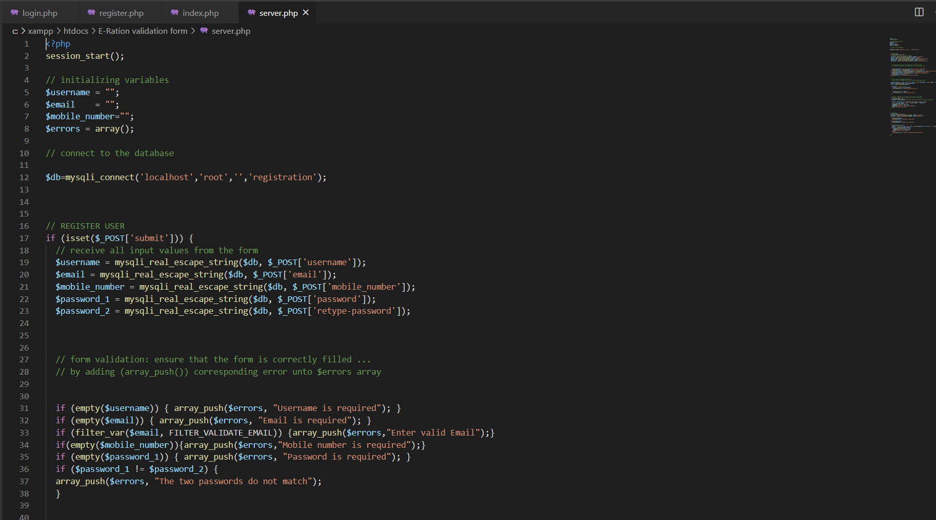

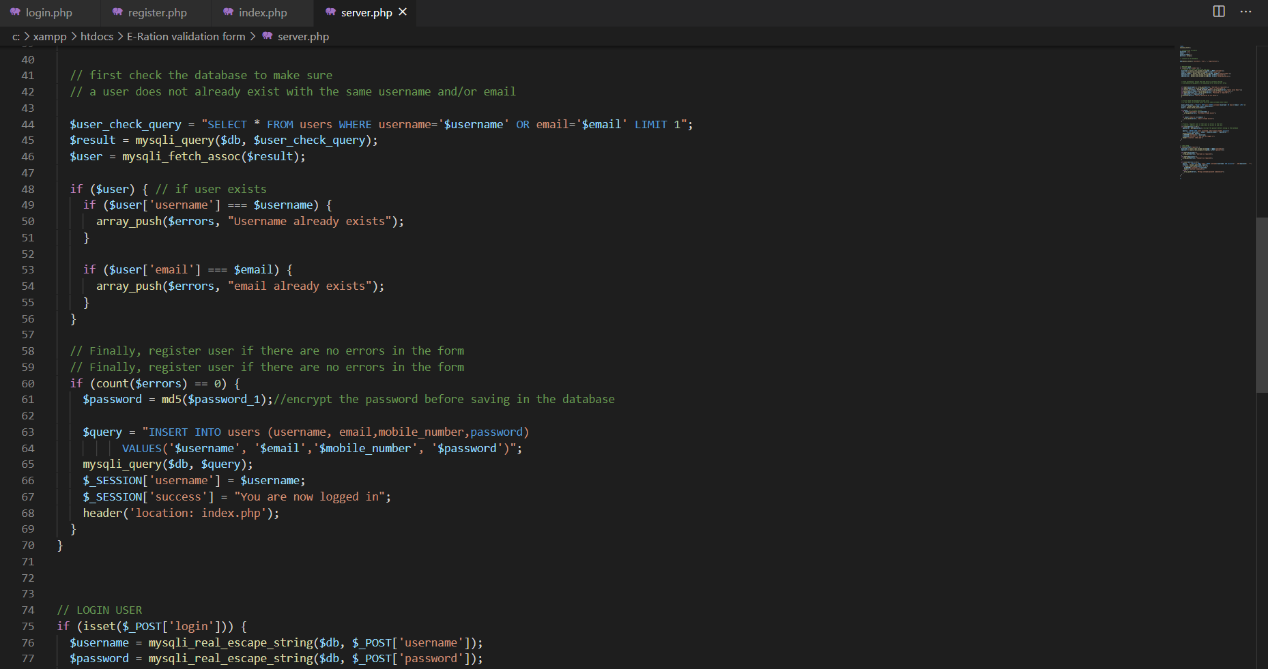

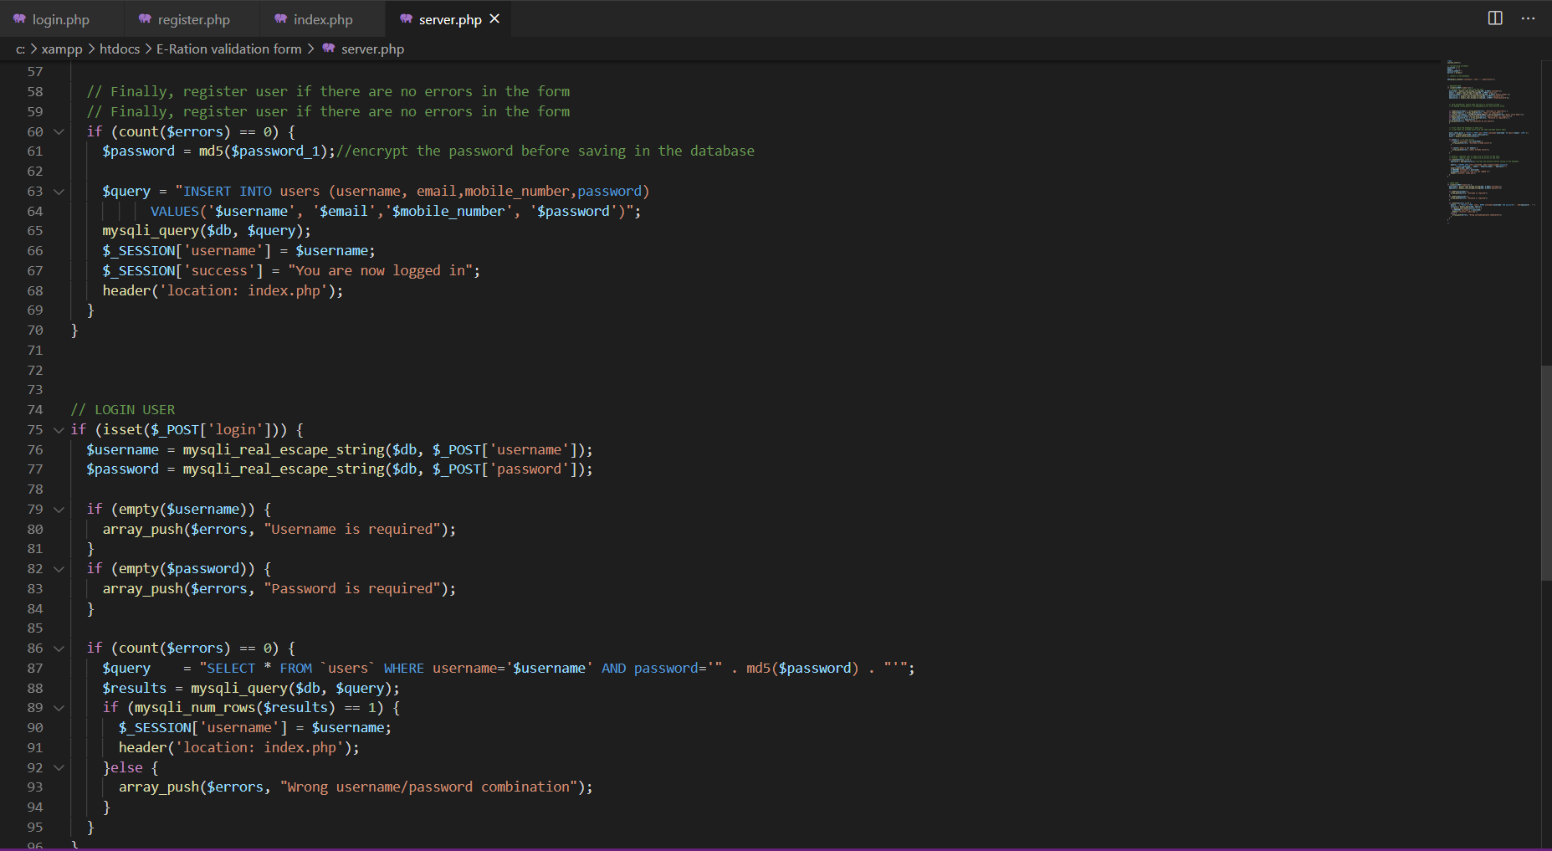

**Server2 Module :**

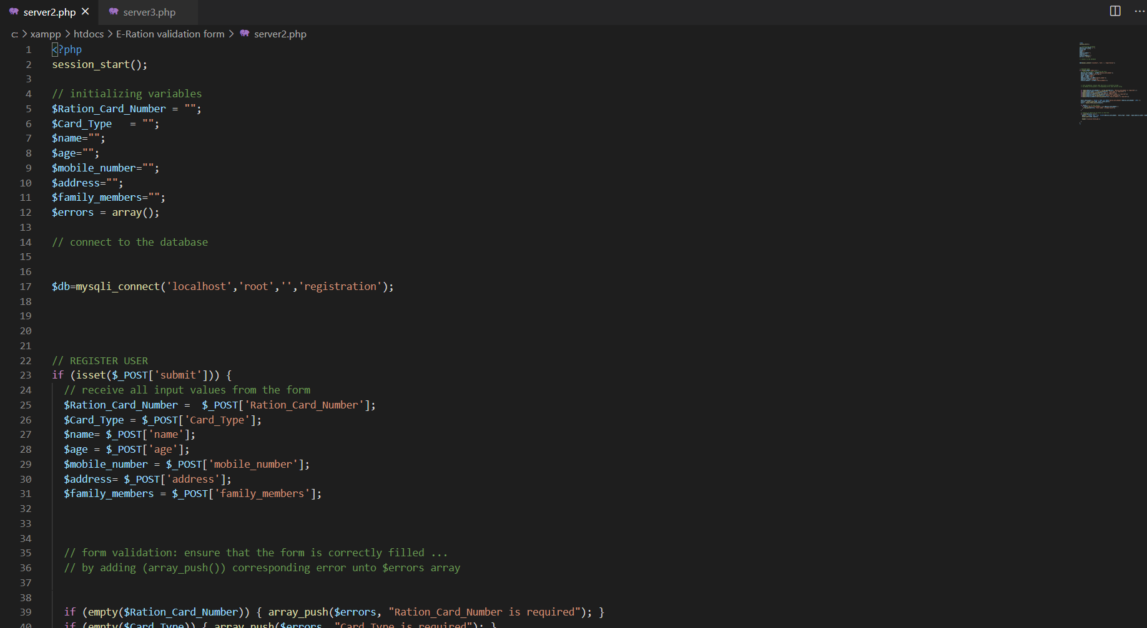

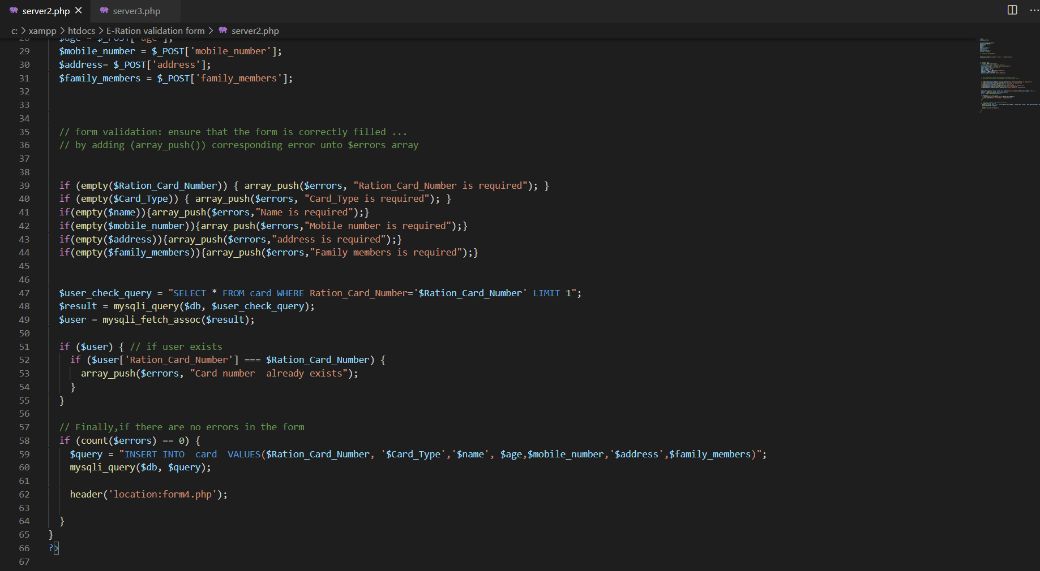

**Result and discussion :**

The project has following front end look

1. **Admin login page**:

In this page, the distributor(admin) can login with his/her credential if he/she has already created their user account, if not there can visit the register page by hitting sign-up.

The page also allows the inspector to login with his/her details and this can be done by visiting to inspector login page.

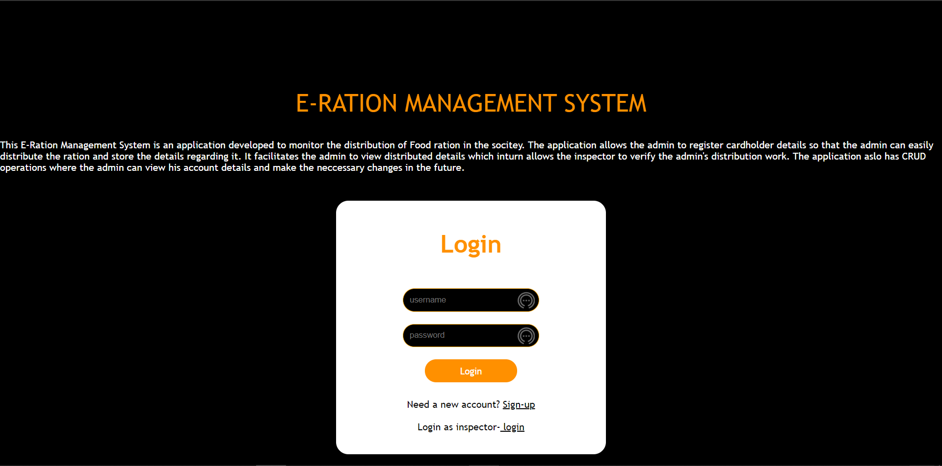

1. **Admin registration :**

The registration page allows the fresh distributor(admin) to create an account for distributing the ration.

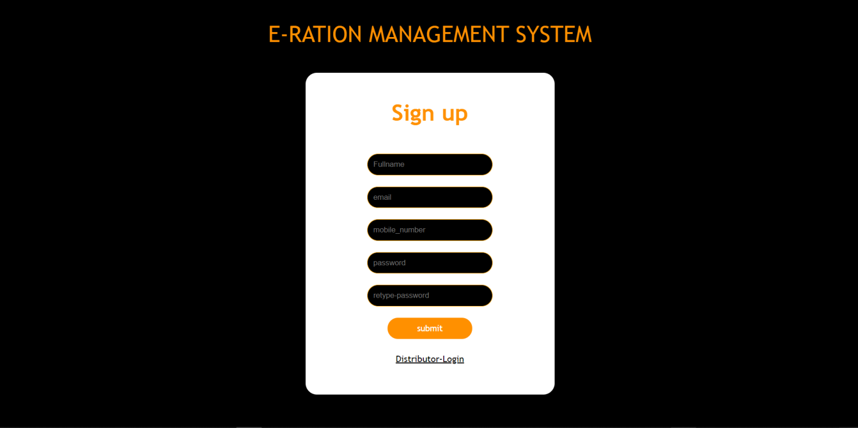

1. **Customer Registration :**

This page allows the distributor to register the details of the customer/cardholders for ration distribution. The page makes it possible for the distributor to account the customer details only once and refer it during the distribution time

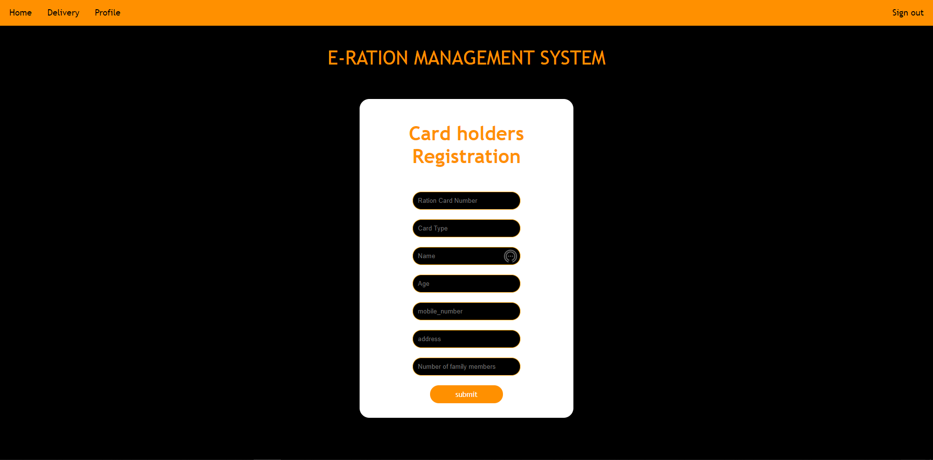

The above page also has a navigation bar which allows the distributor to navigate to delivery page,admin profile and sign out.

1. **Display customer Details** :

This page allows the Distributor to view the customer details by entering ration card number.To distribute the ration ,admin can hit the distribute button.

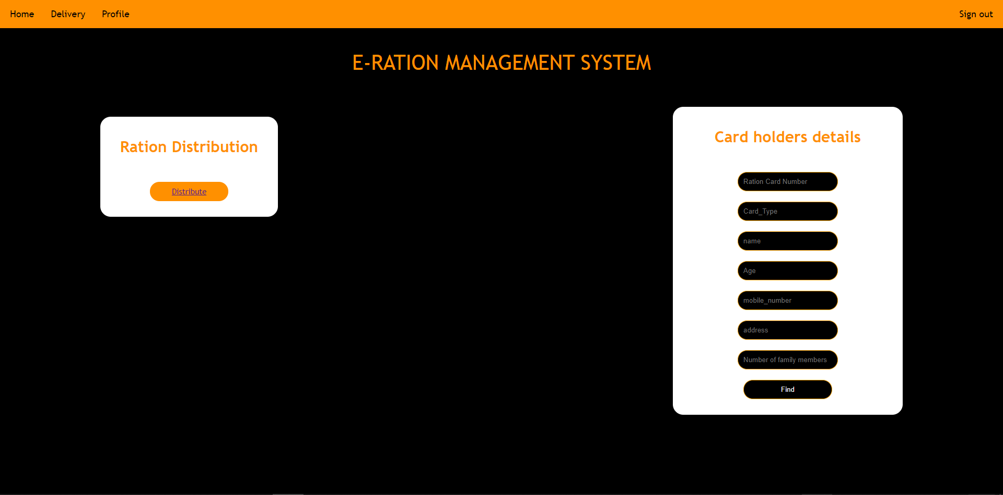

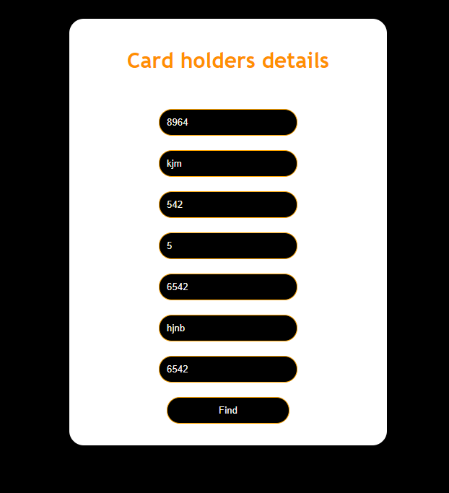 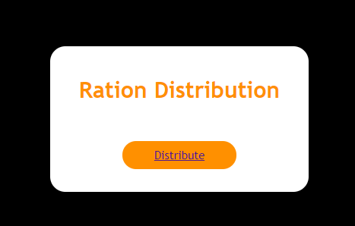

\

1. **Ration Distribution :**

This page consists a form that take customer ration card number to uniquely store the distribution detail and it also has the fields regarding ration items.

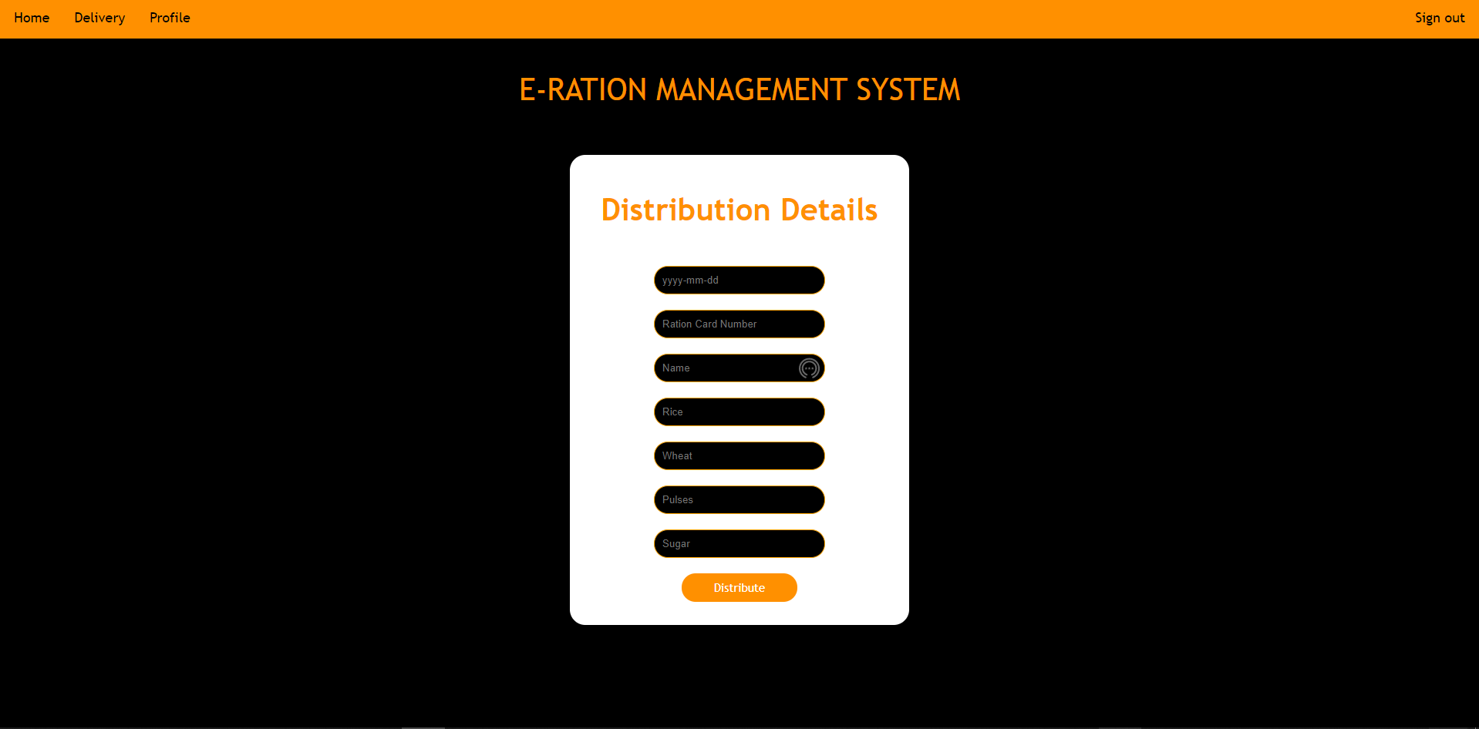

1. **Delivery page :**

The delivery page has the ration distribution details

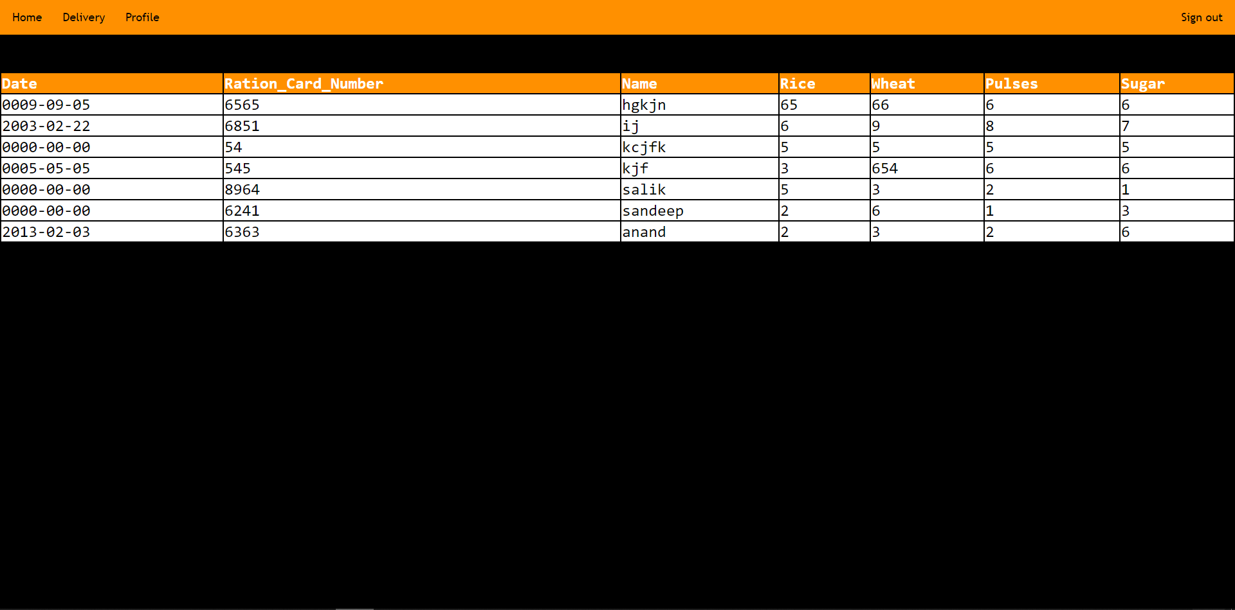

9 **Profile page** :

The profile page contains admin details on he can perform update and delete operation. The admin can delete the his account if not in use or he can just update his username,mobile number and email id.

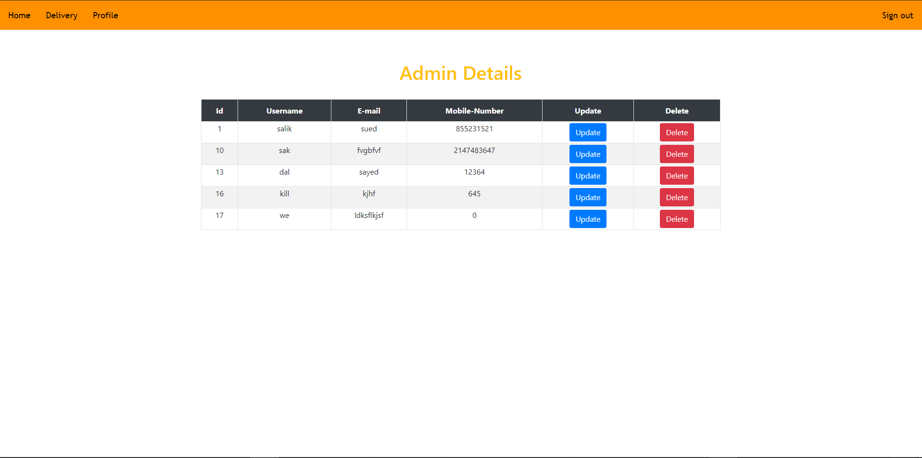

**Conclusion** :

Using the proposed system we can bring transparency at each level of the rationing system thereby eliminating problems such as customer data manipulation and black marketing to a greater extent. This user-friendly web application would enable the admin to know their exact allotted ration of the month. The stored data can be used for future ration distribution. Hence the distributor is confined to his job provided by higher authorities which increases transparency and proper distribution of the ration to the cardholders.

**References** :